STUDENT SCHOLARSHIPS SUPPORT SYSTEM

Project Proposal
V 1.0

By
1 | Amna Khadim | NUM-BSCS-2025-08
2 | Hafsa Munawar | NUM-BSCS-2025-15
3 | Mehwish Eman | NUM-BSCS-2025-27
4 | Talha Nawaz | NUM-BSCS-2025-58



Department of Computer Sciences
Namal University
Mianwali, Pakistan
Submission Date : 9th October, 2026
REVISION HISTORY
Date | Version | Description | Approved by
08 October 2026 | V 1.0 | Initial version of the Project Requirements Specification and project proposal submitted for approval. | Sir Ammar Ahmed Khan

TABLE OF CONTENTS
1. INTRODUCTION: 5
2. PROBLEM STATEMENT: 5
3. PROJECT OBJECTIVES: 5
4. PROJECT SCOPE: 6
5. STAKEHOLDER IDENTIFICATION: 7
6. SOFTWARE DEVELOPMENT METHODOLOGY: 8
7. TOOLS AND TECHNOLOGIES: 11
REFERENCES 12

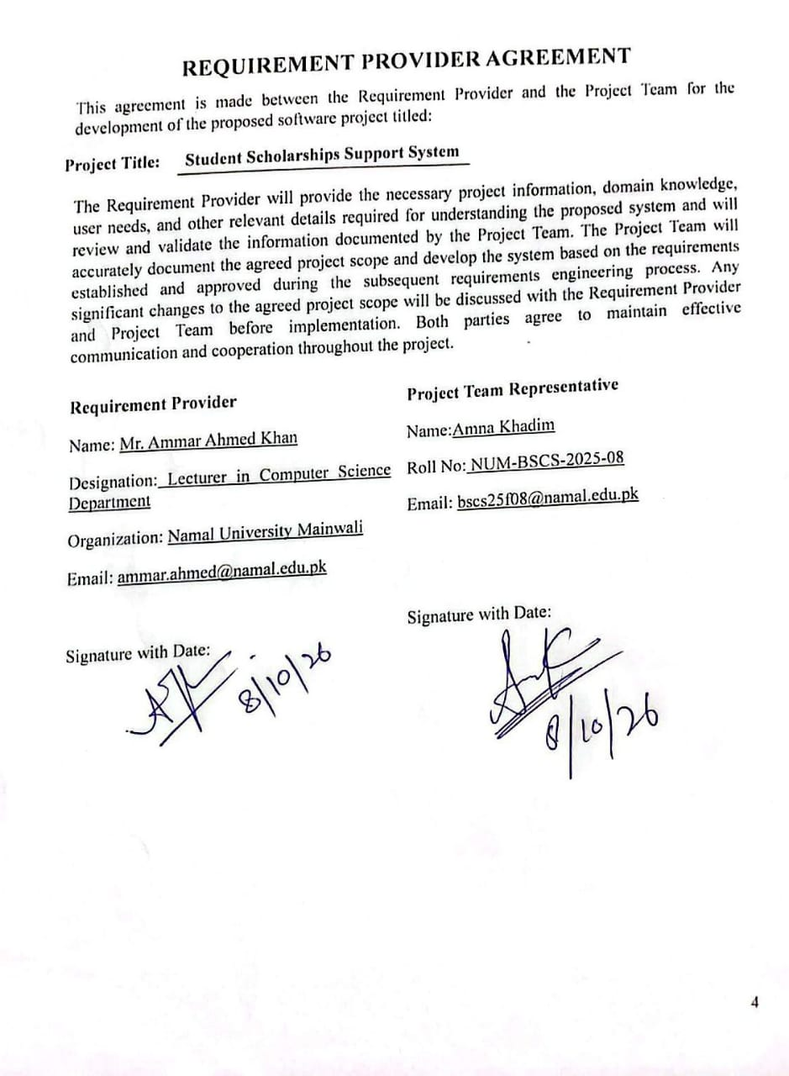

INTRODUCTION:
Many students struggle to find scholarships. Opportunities are scattered across different websites, eligibility requirements and deadlines are often ambiguous, and students miss out on scholarships that are a good fit because they don’t know where to look. This project was born out of a need for a single, organized source of information.
The Student Scholarship Support System is a proposed web-based platform to consolidate scholarship information both local and international into one place. Students can upload their CV and choose the countries they want to study. They then can search and filter scholarships and see details like eligibility criteria, requirements, benefits and deadlines. In the full system, students will be matched to scholarships best suited to their profile by AI based recommendations.
It is a project in the area of education and student services. Why it matters: It saves students time, reduces missed opportunities, and makes scholarships easier to access, especially for students who lack guidance on where to apply.

PROBLEM STATEMENT:
International scholarship information is all over the place—on university websites, scholarship portals, official announcements and even professor profiles—and it is hard for students to find relevant opportunities. Students often face difficulties in identifying scholarships, universities and potential supervisors that are compatible with their educational qualifications, research interests and career aspirations. Learning about eligibility requirements, what to include in an application, deadlines and what supervisors are researching takes a lot of time and effort, especially for students with little academic guidance. Moreover, preparation of tailored application documents (e.g. CVs, cover letters, research proposals and emails) can require a significant amount of time. These challenges make it difficult for students to identify appropriate opportunities, to prepare effective applications and to keep track of important deadlines.

PROJECT OBJECTIVES:
The main objective of the Scholarship Management System is to simplify scholarship discovery and application management through an organized and intelligent platform. The key objectives are:
- Centralized scholarship platform: To build a web prototype with user registration and login, student profile management (CV upload and preferred study country), and an admin login with dashboard, enabling students and administrators to manage their information in one place.
- Efficient Scholarships Discovery: To provide scholarship cards, detailed scholarship pages, search, filtering (country, degree level, field of study) and clear display of eligibility criteria so that a student can find a suitable scholarship in a few steps.
- Timely notification and Tracking: To implement the notification system to alert the students and to keep the students informed. Keep applications organized.To add simple notifications for deadlines and other updates in the prototype then expand them to email and SMS alerts with application tracking in the full system.
- Intelligent Automation: To add AI based scholarship suggestions from the student CV and preferences in later stages, document verification, automatic application processing, data analysis and insights, advanced admin controls.

- PROJECT SCOPE:
4.1 INCLUSION:
- User Registration and Login: Basic student registration, login and logout features.
- Student Profile Management: View and edit basic personal and academic information.
- Admin Dashboard: Basic dashboard to manage scholarship records and view applications.
- Scholarship Management: Admin can Create, View, Update and delete Scholarship listings.
- Scholarship Search & Filtering: Search and filter scholarships by country, field of study, eligibility, funding type and deadline.
- Application & Eligibility: List scholarship descriptions, eligibility requirements, documentation needed, funding and application deadlines.
- Scholarship Application: Complete an internal application form in the system to apply for a scholarship.
- Application Status Tracking: Enable students to check the status of their submitted applications in the system.
- Basic Notifications: Show simple notifications about application status and upcoming deadlines.
- Basic Data Management: Store and retrieve user, scholarship, and application records using the selected database, where implemented.
- Responsive User Interface: Offer a comfortable user interface that functions on common desktop and mobile screen sizes.
We will build out the core interface and prototype functionality over the first four months. The rest of the project time will be used to extend the system with chosen advanced features depending on the time, technical resources and project needs.
4.2 EXCLUSION:

- AI-Powered Suggestions: Advanced recommendation algorithms and AI align scholarships with your individual profile.
- CV-based Matching: Parse CVs automatically and get scholarship recommendations based on the CVs uploaded.
- AI Email Generation: Automatic generation of customized emails to professors or prospective supervisors.
- External Application Submission: Submission of scholarship application directly through external university or scholarship provider portals.
- Advanced Analytics: predictive analytics, complex reports and advanced insights on student activity.
- Advanced Automation: Automated email, SMS or messaging-service reminders requiring integration with an external service. Document verification automatic checking of transcripts, certificates and other supporting documents.
In the second phase, depending on feasibility, available resources and the approved project plan, selected advanced features may be considered.
4.3 CONSTRAINTS AND LIMITATIONS:
- Time constraint: The project will be developed during a proposed period of one year, where the first four months will be dedicated to the core prototype and the remaining time will be allocated for the planned extensions.
- Technical Limitations: The development will be made in HTML, CSS and JavaScript for the user interface, Node.js and Express.js for the server-facing functionality and MySQL as the database to be used.
- Learning and Development Resources: Technical skills of the team will limit complexity in implementation.
- Data Availability: Initially, the administrator will input and update scholarship information manually or gather it from verified public sources. There is no guaranty that all international scholarships will be fully and up to date covered.
- External Dependencies: Third party APIs, university integrations and AI services will be subject to API access, availability, relevant usage limits and any associated costs.
- Prototype and testing limitations: Testing will initially focus on core functionality, usability and common user workflows. The initial prototype does not involve large scale performance testing and enterprise level deployment.
- Security constraints: Basic access control and sufficient protection of user information will be implemented. Production-level security certification and formal security audits are not part of the current project scope.
- Limitations of the Application: The platform will track applications submitted but does not guaranty scholarships will be approved or that applications will be automatically submitted to external institutions.
- Platform Constraint: The system will be developed as a web based application. Does not include standalone native mobile apps.
- Feature prioritization: Advanced AI features, automated integration's and analytic will only be developed if they can be delivered within the approved schedule and available resources
- STAKEHOLDER IDENTIFICATION:

Stakeholder | Role | Interaction with System
Student/ Applicants | Main users who search and apply for suitable international scholarships | Upload CV, enter academic information and interests, view matched scholarships and supervisors, generate application materials, track applications, and receive reminders and notifications.
Supervisors/ Professors | Academic professionals who may guide or supervise students for research or higher education opportunities | Their academic profiles and research interests are used for supervisor matching. They may receive and respond to student emails or proposals
System Administrator | Manages and maintains the overall system. | Manages users, scholarship records, university and supervisor data, system settings, security, and system performance.
Scholarship/ University Data Managers | Maintain information about scholarships, universities, eligibility criteria, and deadlines. | Add, update, and verify scholarship and university information in the system.
System Development Team | Develops and maintains the software system | Designs, implements, tests, updates, and fixes the system and its integrated features.
Client | Proposed the idea and defines the project requirements | Review prototype progress, gives feedback and approves deliverables

- SOFTWARE DEVELOPMENT METHODOLOGY:
The project will follow the Agile Software Development Methodology, an iterative approach in which the system is developed and tested in smaller increments. This methodology is suitable for the proposed portal because it consists of multiple modules, including student profile management, opportunity search and filtering, supervisor matching, deadline notifications, AI-assisted document generation.
6.1 PHASES OF DEVELOPMENT:
The project will be divided into manageable development iterations. Each module will be planned, developed, tested, and reviewed before moving towards complete system integration. Feedback and identified issues will be addressed during subsequent iterations. This approach will provide flexibility for changes in requirements, support continuous testing, and help identify technical issues at an early stage.
The development process will include the following major phases:
- Planning: Define project scope, objectives, team roles, tools, risks, and schedule. Create the initial product backlog (prioritized list of features) Approve the project.
- Requirement Analysis: Gather requirements through student and supervisor surveys or interviews, and existing scholarship portals review. Write the SRS with Functional requirements and Non-functional requirements.User stories Before each sprint, the backlog is groomed to refine the requirements.
- System Design: Design the overall architecture (React.js frontend, Node.js/Express backend, MySQL database), ERD and database schema, UML diagrams, and Figma UI/UX prototypes. At the module level, design is detailed at the beginning of each sprint.
- Implementation: The portal should be developed in incremental module releases. Each module is developed from end to end (UI, API, database) over a few sprints
- Testing:Testing is done in every sprint: unit testing by developers, module and integration testing at the end of the sprint and full system testing and User Acceptance Testing (UAT) toward the end. Bugs are logged in and corrected in the next sprint..
- Integration and Deployment: Integrate all modules, conduct final end-to-end testing, fix outstanding bugs, deploy to hosting server and handover documentation and user guide.
Phase / Duration | Focus Area | Detailed Activities & Key Deliverables
Month 1–2 | Requirements & System Design | Requirement gathering and analysis  SRS document preparation  Figma UI/UX design  ERD and database schema design  Project approval
Month 3–6 | Frontend Development | Develop user interface using HTML/CSS, JavaScript & React.js  Student registration and profile management  Scholarship search and filtering directory  Supervisor profile search and listing  Student dashboard for deadline tracking  Document generator forms for SOPs, cover letters, and emails
Month 7–9 | Backend & AI Development | Set up MySQL database  Develop backend APIs using Node.js/Express  Integrate OpenAI API for scholarship recommendations  Develop AI-based document generation  Implement supervisor profile matching algorithm
Month 10-12 | Integration, Testing & Deployment | Connect frontend with backend API  Implement deadline email notifications  Perform end-to-end system testing  Fix bugs and improve system performance  Final system deployment
6.2 TEAM ORGANIZATION AND MONITORING:
6.2.1 ROLES:
- Product Owner: Represents the users. Owns and prioritizes the product backlog. (Project manager or team leader.
- Scrum master: Facilitates the process, removes obstacles and keeps the team on schedule.
- Development Team: Frontend developer(s), backend/database developer(s) and a tester. Members share responsibilities if needed.
6.2.2 SCRUM ACTIVITIES:
- Sprint Planning: Each sprint starts with the team selecting backlog items and breaking them down into tasks.
- Daily Stand-up: Short meeting to cover what was done, what's next and any blockers.
- Sprint Review: At the end of each sprint, the working increment is presented to the supervisor and sample users.
6.2.3 MONITORING TOOLS:
- Jira board (To Do, In Progress, Testing, Done) to track tasks.
- GitHub for version control, which separate the branches for each features.
- Milestones checks at the end of each release against the Gantt Chart.
6.3 FEEDBACK INCORPORATION:
- Feedback is collected from the supervisor, instructor, and a small group of test users (students) at each sprint review.
- A Figma prototype is shared with users before any coding takes place, so interface issues are fixed at the beginning.
- We log feedback and bug reports in the product backlog, and prioritize them by importance and schedule them in upcoming sprints.
6.4 MANAGING CHANGE:
- A change request (new feature, changed requirement or defect) is documented and added to the product backlog.
- The team and Product Owner assess the impact on scope, time, effort and other modules.
- If approved, the item is given priority and scheduled in a future sprint. Changes are not made in the middle of a running.

6.5 GANTT CHART:

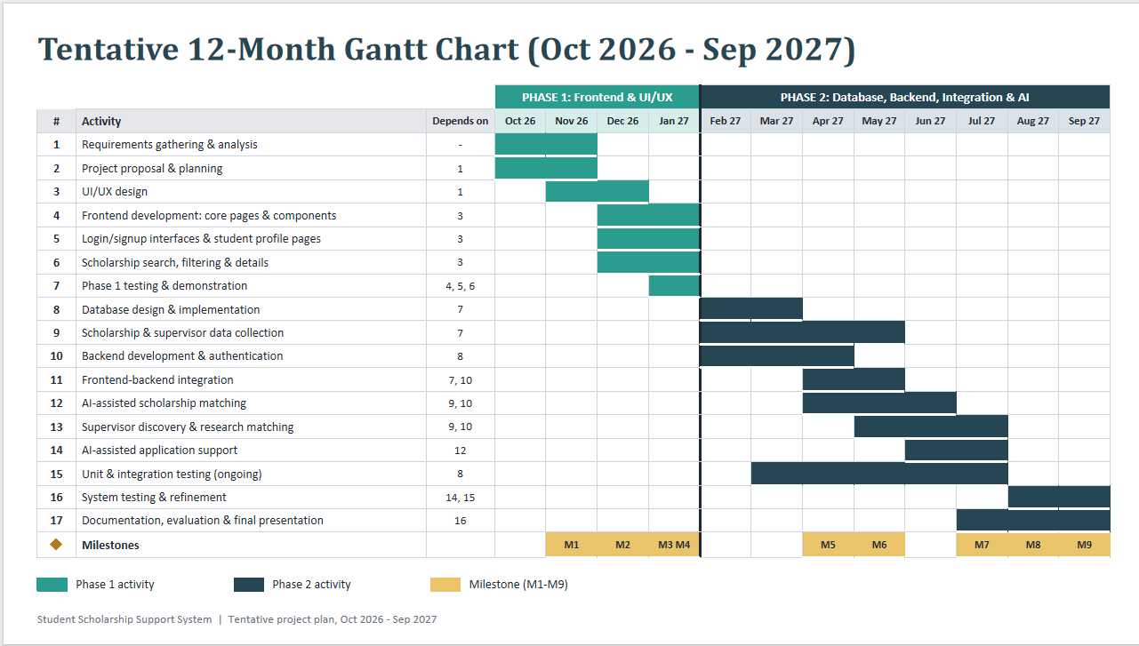
- TOOLS AND TECHNOLOGIES:
The following tech stack will be utilized to design, build, and deploy the system:
- UI/UX Design: Figma
- Frontend Stack: HTML, CSS, JavaScript , React.js
- Backend Stack: Node.js, Express.js
- Database Management: MySQL / Relational Database System
- API Integration: Gemini API (for recommendation and document drafting guidance)
- Tools & Environment: GitHub (Version Control),VS Code (IDE)
Technology / Tool | Description | Justification
Figma | Design wireframes, prototypes, and UI layouts. | Allows UI approval and improves user experience before development.
HTML5, CSS3, JavaScrip & React.js | Develop the frontend, interactive forms, navigation, and responsive interfaces. | React.js provides reusable components, efficient rendering, and smooth user interaction.
Node.js & Express.js | Handle server-side logic, requests, and RESTful API development. | Lightweight, scalable, and provides efficient communication between frontend, database, and AI services.
MySQL | Store student profiles, scholarship records, supervisor information, and other system data. | Provides data integrity, structured relationships, and efficient search queries.
Gemini API | Provide AI-based scholarship recommendations, supervisor matching, and document generation. | Enables personalized recommendations and automated generation of SOPs, cover letters, and outreach emails.
VS Code | Write, edit, and debug project code. | Provides an efficient development environment with useful extensions and debugging support.
GitHub | Manage and store the project's source code. | Supports version control, collaboration, and secure code management.

REFERENCES
[1]“Scholarships,”Mastersportal.[Online].Available:https://www.mastersportal.com/scholarships/ [Accessed: Oct. 2, 2026].
[2]"ScrumArtifactsExplained",SkillifySolutions.[Online].Availableat:https://skillifysolutions.com/blogs/scrum-master/scrum-artifacts-explained/ (Accessed: Oct. 5, 2026).
[3] OpenAI, “ChatGPT conversation about the Student Scholarship Support System project.” [Online]. Available:https://chatgpt.com/c/6ac32735-ac14-83ec-ade8-7aa282b7596d. [Accessed: SEP. 29, 2026].
[4] OpenAI, “ChatGPT conversation about the Student Scholarship Support System project.” [Online]. Available:https://chatgpt.com/c/6ac3b34b-6160-83ec-9905-3bbf7202c1d0 [Accessed: Oct. 2, 2026].
[5] OpenAI, “Claude converstion about the Gantt Chat of our project.”[Online]. Available: https://claude.ai/chat/c19886f2-e35b-4d60-b2cf-f4c7aa4e4bc2 [Accessed: Oct. 8, 2026].

